SIMATS ENGINEERING
Department of Computer Science and Engineering
 CSA15 Cloud Compu.ng and Big Data Analy.cs
CO2 AT3 - Capstone Cloud Infrastructure Case
Analysis and Defense
Editable student template for applica8on-based cloud virtualiza8on and SDDC/cloud opera8ons defense

Assessment Metadata
Course Code | CSA15
Course Title | Cloud Compu8ng and Big Data Analy8cs
Assessment | CO2 AT3 - Capstone Cloud Infrastructure Case Analysis and Defense
Submission Type | Individual digital case analysis and infrastructure defense based on the same capstone 8tle used in CO1, CO2 AT1 and CO2 AT2
Faculty | Dr C. Rajesh Babu
Employee ID | SSETSCS415
Submission Mode | Completed DOCX template and GitHub repository link through  Google Classroom

How This Template Works
- Use the same capstone 8tle used in CO1, CO2 AT1 and CO2 AT2.
- Do not recalculate all VM sizing or repeat all configura8on screenshots. Summarize the final AT1/AT2 evidence and use it for design defense.
- Answer all five ques8ons with applica8on-oriented reasoning connected to the capstone product.
- Include sustainable cloud opera8on decisions wherever relevant: right-sized resources, log reten8on, storage lifecycle, scheduled shutdown, API-call reduc8on and VM/container/serverless comparison.
- Paste the final topology diagram in the given response area. The sample diagram is only a structure; redraw it for the student's own product.
- Upload this completed document and suppor8ng evidence to GitHub, then submit the repository link through Google Classroom.
Assessment Focus
AT1 answered what VM is required. AT2 showed configura8on or simula8on evidence. AT3 asks whether the student can defend the complete infrastructure design under applica8on, security, opera8ons and failure condi8ons.

Student and Capstone Details
Student Name | Krishnan Gupta M
Register Number | 192524062
Class / Slot | Slot C
Capstone Title | HostelMate Green Cloud: Sustainable Hostel  Management with Energy-Efficient SLA Op8miza8on and  Geo-Tagged Complaint Intelligence
CO1 Evidence Link
CO2 AT1 VM Recommenda.on | vCPU: 2 RAM: 4 GB Storage: 50 GB  VM Class: General Purpose (B2s)
CO2 AT2 Evidence Link
GitHub Repository Link | https://github.com/192524062simats-ops/CSA1517cloud-computing-
Submission Date | 04-08-2026

Evidence Carry-Forward Summary
Evidence Source | Student Entry | How It Supports AT3 Defense
CO1 concept map / presenta.on | Problem statement, SDG 11 & SDG 12 objec8ves, system modules and cloud architecture | Demonstrates the project objec8ves, cloud-based design, and sustainability goals.
CO2 AT1 sizing workbook | VM recommenda8on: 2 vCPU, 4 GB  RAM, 50 GB Storage, General  Purpose VM | Jus8fies the selected infrastructure size and resource alloca8on for the applica8on.
VM calibra.on sheet | Performance es8ma8on and resource u8liza8on analysis | Confirms that the selected resources are adequate for the expected workload.
CO2 AT2 prac.cal evidence | Firebase setup, Cloudinary integra8on, Flueer applica8on, security configura8on, and GitHub repository | Demonstrates successful implementa8on, deployment readiness, and secure cloud configura8on.
Capstone architecture decision | Firebase Authen8ca8on, Firestore,  Firebase Storage, Cloud Func8ons,  Cloudinary, Google Maps API, React  Dashboard | Supports the final cloud architecture, scalability, automa8on, security, and Green Cloud objec8ves.

Q1: Virtualiza.on Value and Capstone Cloud Deployment Summary
Explain your capstone product, expected workload, cloud need and deployment context. Analyze how virtualiza8on improves cost efficiency, resource u8liza8on, workload isola8on, infrastructure flexibility and cloud deployment readiness for your product.
Design Point |  | Student Response
Capstone product and users |  | HostelMate Green Cloud is a cloud-based hostel complaint management system used by students, wardens, maintenance staff, vendors, and administrators to report, manage, and monitor hostel maintenance issues efficiently.
Expected workload |  | The applica8on handles daily complaint submissions, image uploads, loca8on tagging, no8fica8on delivery, analy8cs processing, and mul8ple users accessing the system simultaneously.
Cloud need |  | Cloud infrastructure provides scalable storage, secure authen8ca8on, real-8me database synchroniza8on, serverless processing, and anywhere access without maintaining physical servers.
Virtualiza.on value |  | Virtualiza8on allows cloud providers to efficiently share physical hardware among mul8ple services, improving resource u8liza8on, scalability, isola8on, and system reliability.
Cost and u.liza.on benefit |  | Instead of purchasing dedicated servers, the project uses Firebase managed cloud services that automa8cally allocate resources based on demand, reducing opera8onal cost and minimizing idle resources.
Isola.on and flexibility benefit |  | Each cloud service such as Authen8ca8on, Firestore, Storage, Cloud Func8ons, and Cloudinary operates independently. This modular architecture simplifies maintenance, improves security, and allows future feature expansion.
Case Analysis Response: Write 8-12 technical lines connec.ng virtualiza.on value to your capstone product.
HostelMate Green Cloud is developed to automate hostel maintenance management through cloud compu8ng. Students can submit complaints with photos and GPS loca8ons using the Android applica8on. Firebase provides authen8ca8on, real-8me database services, cloud storage, and serverless backend processing. Virtualiza8on enables efficient alloca8on of compu8ng resources without requiring dedicated physical servers. Cloud Func8ons automa8cally process complaint rou8ng and SLA monitoring. Firestore synchronizes complaint data across all users in real 8me. Cloudinary stores and op8mizes uploaded images, reducing storage overhead and improving delivery performance. Managed cloud services increase reliability, scalability, and fault tolerance while lowering infrastructure costs. The modular cloud architecture also simplifies maintenance and future upgrades. Overall, virtualiza8on makes the applica8on flexible, energy efficient, and suitable for sustainable cloud deployment.

Q2: Rapid Provisioning, Tes.ng and Virtual Machine Lifecycle Case
Using your CO2 AT1 VM recommenda8on and CO2 AT2 prac8cal evidence, explain how virtual machines, VM images, templates, snapshots, clones or containers support rapid provisioning, tes8ng, deployment, rollback and maintenance for your capstone product.
Lifecycle Element | AT1/AT2 Evidence Used | Capstone Use / Jus.fica.on
VM image or base environment | Firebase Project + Flueer SDK | A standard Flueer and Firebase development environment is used for all developers to maintain consistency.
Template or repeatable setup | Firebase project configura8on and  GitHub repository | New developers can clone the repository and configure Firebase quickly using the exis8ng project setup.
Snapshot / rollback | GitHub Version Control and  Firebase Backup | Previous applica8on versions can be restored if deployment introduces errors or failures.
Clone / tes.ng copy | GitHub Branches and Firebase Test  Project | Separate tes8ng copies are created before deploying new features to produc8on.
Container or VM decision | Firebase Console and Cloud  Func8ons | Updates are deployed with minimal down8me while monitoring performance through Firebase Console.
Maintenance and update plan
Case Analysis HostelMate Green Cloud uses managed cloud services to simplify applica.on deployment and maintenance. The Flu^er applica.on is developed using a standardized Firebase environment, allowing quick setup for every developer. GitHub stores the complete source code, enabling version control, branching, and rollback whenever issues occur. A separate Firebase tes.ng project is used to validate new features before produc.on deployment. Since Firebase provides serverless backend services, virtual machine management is not required, reducing opera.onal complexity and maintenance costs. Cloud Func.ons automa.cally execute backend tasks such as complaint rou.ng and SLA monitoring without manual server configura.on. Cloudinary securely stores uploaded complaint images while op.mizing delivery performance. This lifecycle approach reduces deployment .me, minimizes down.me, improves reliability, and supports con.nuous development with lower infrastructure risk.Response: Explain how lifecycle prac.ces reduce deployment delay and risk.

Q3: Final Cloud Deployment Topology and SOA/API Service Integra.on Case
Draw and explain the final deployment topology for your capstone product. Show frontend, backend/API, database, storage, authen8ca8on, no8fica8on, analy8cs and any VM/container/managed cloud service components. Explain how SOA/API-based integra8on connects these modules and supports modular cloud service design.
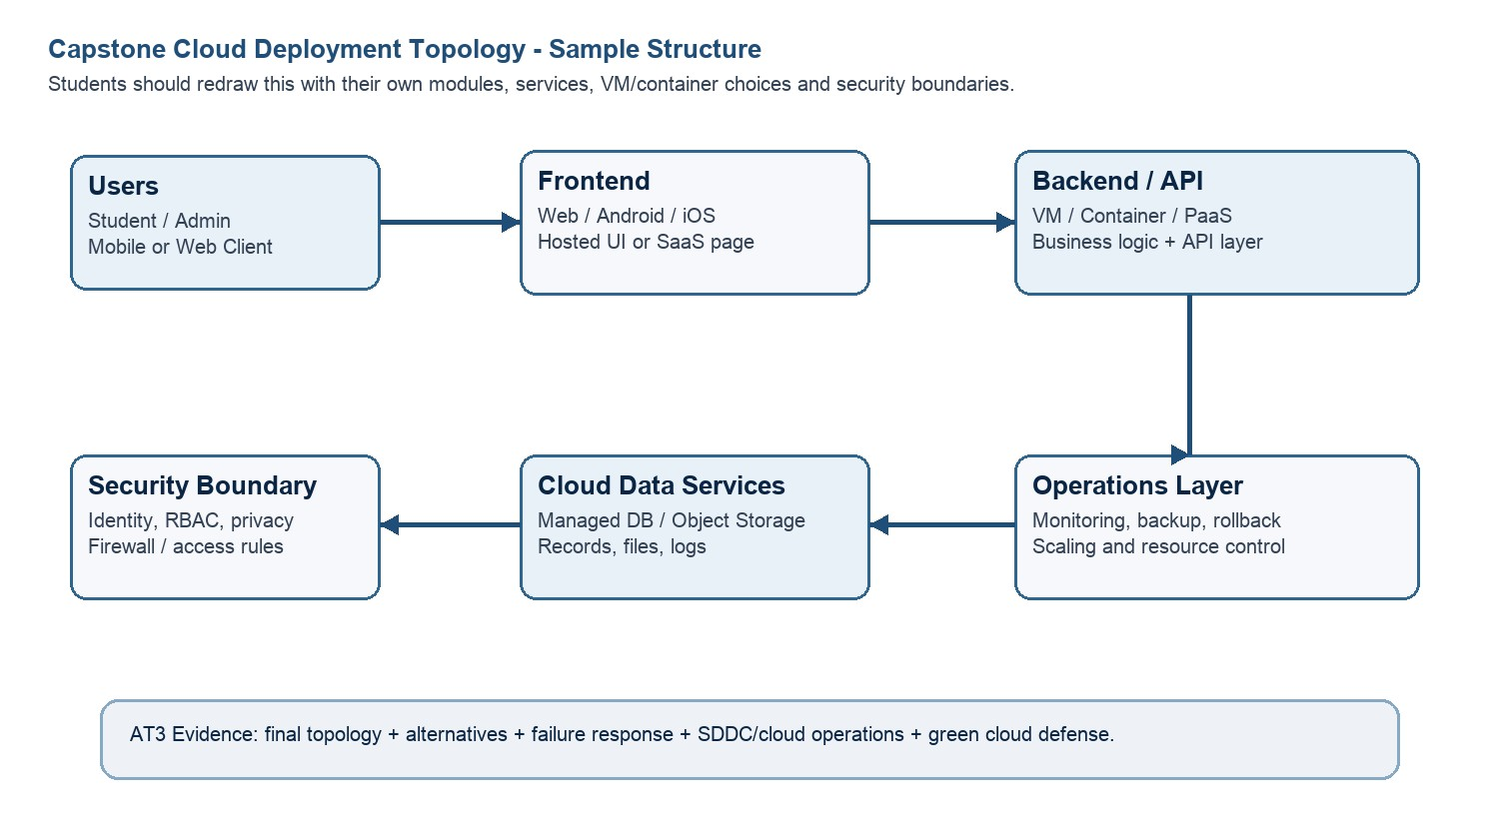
Architecture Component | Technology / Service | VM / Container / Managed Service /  SaaS | Integra.on Method
Frontend | Flueer Android App | Client Applica8on | Uses Firebase SDK and  REST APIs
Backend/API | Firebase Cloud Func8ons | Managed Serverless  Service | Triggered by Firestore events and HTTPS APIs
Database | Firebase Firestore | Managed NoSQL  Database | Real-8me synchroniza8on with  Flueer
Storage | Firebase Storage +  Cloudinary | Managed Cloud Storage | Stores complaint images and retrieves image URLs
Authen.ca.on | Firebase Authen8ca8on | Managed Authen8ca8on  Service | Email/Password login with Role-Based Access  Control
No.fica.on | Firebase Cloud  Messaging (FCM) | Managed No8fica8on  Service | Sends complaint status and SLA no8fica8ons
Analy.cs / AI module | Python Analy8cs | Managed/Cloud Hosted | Reads Firestore data for SLA reports, priority analysis, and complaint trends
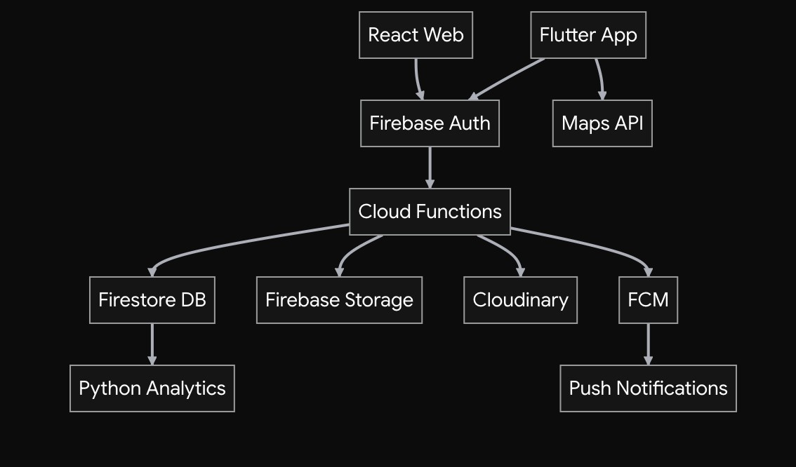
Paste or draw the
fi
nal capstone deployment topology diagram here.

SOA/API Integra.on Explana.on: Explain how services communicate and why modular service design is useful.
HostelMate Green Cloud follows a Service-Oriented Architecture (SOA) using mul8ple independent cloud services. The Flueer applica8on communicates with Firebase Authen8ca8on for secure user login and Firestore for storing complaint informa8on. Images uploaded by users are stored in Firebase Storage and Cloudinary, while Google Maps API provides loca8on tagging for each complaint. Firebase Cloud Func8ons automate 8cket assignment, SLA monitoring, and workflow processing without requiring dedicated servers. Firebase Cloud Messaging sends real-8me no8fica8ons to students and maintenance staff whenever complaint statuses change. The Python Analy8cs module processes complaint data to generate reports, iden8fy recurring infrastructure issues, and evaluate vendor performance. The React web dashboard displays analy8cs and complaint management informa8on for administrators. This modular architecture improves scalability, simplifies maintenance, enhances security, and allows each service to be updated independently without affec8ng the en8re applica8on.

Q4: Design Alterna.ves, Iden.ty, Access and Federated Cloud Privacy Case
Compare at least two deployment alterna8ves for your capstone product, such as single VM, mul8-8er VM, containerized deployment, managed backend, federated cloud or hybrid cloud model. Jus8fy the selected design by analyzing iden8ty management, role-based access control, federated access, data sharing, privacy protec8on and security risks.

Deployment Alterna.ve | Advantages | Limita.ons / Risks | Iden.ty and Privacy Impact
Alterna.ve 1 | Easy to deploy and manage for small applica8ons. | Limited scalability, higher maintenance, manual updates, and single point of failure. | User authen8ca8on and data security depend en8rely on the VM configura8on, increasing security risks.
Alterna.ve 2 | Automa8c scaling, serverless architecture, high availability, built-in authen8ca8on, lower maintenance, and beeer reliability. | Vendor lock-in and dependency on internet connec8vity. | Secure authen8ca8on, encrypted data transmission, and rolebased access control improve user privacy and security.
Selected design | Firebase Managed Cloud with Cloudinary | Best balance of scalability, security, cost, and opera8onal efficiency. | Provides secure iden8ty management and  protects sensi8ve hostel complaint data.
Security Area |  | Student Decision
User roles |  | Student, Warden, Maintenance Staff, Vendor,  Administrator
Authen.ca.on method |  | Firebase Authen8ca8on using Email and Password
Role-based access control |  | Firestore Security Rules restrict users based on their assigned roles. Students can access only their complaints, while administrators and staff have addi8onal permissions.
Federated access / partner access |  | Vendors receive access only to maintenance 8ckets assigned to them. They cannot view unrelated hostel data.
Sensi.ve data handled |  | Student details, complaint descrip8ons, hostel loca8ons, uploaded images, maintenance history, and SLA records.
Privacy protec.on decision |  | Firebase Authen8ca8on secures user iden8ty, Firestore Security Rules prevent unauthorized access, HTTPS encrypts data in transit, and Cloudinary securely stores complaint images.
Case Analysis Response: Defend why the selected design is be^er for iden.ty, access and privacy.
HostelMate Green Cloud considered both a tradi8onal virtual machine deployment and a managed cloud backend architecture. A single virtual machine requires manual server maintenance, sopware updates, resource scaling, and security management, making it less suitable for a growing applica8on. The selected design uses Firebase managed cloud services with Cloudinary, which automa8cally provide scalability, availability, and serverless infrastructure management. Firebase Authen8ca8on verifies user iden88es, while Firestore Security Rules enforce role-based access control for students, wardens, maintenance staff, vendors, and administrators. Vendors can access only the maintenance tasks assigned to them, protec8ng hostel data from unauthorized access. Sensi8ve informa8on, including complaint details, loca8ons, and uploaded images, is securely stored using encrypted cloud services. This architecture improves privacy, reduces opera8onal complexity, lowers maintenance costs, and provides a secure and scalable plaqorm for sustainable hostel management.

Q5: Sobware-Defined Datacenter and Cloud Opera.ons Defense Case
Analyze how your infrastructure will respond to opera8onal and failure scenarios such as VM failure, database growth, traffic spike, creden8al leakage, service outage, resource conten8on or cost increase. Explain how SDDC concepts and cloud opera8ons prac8ces such as automated provisioning, sopware-defined networking, sopware-defined storage, monitoring, logging, backup, rollback, scaling, resource control and maintenance improve the final infrastructure design. Include Green Compu8ng decisions such as resource right-sizing, storage lifecycle control, log reten8on, API-call reduc8on, scheduled shutdown, VM/container/ serverless comparison and carbon/energy proxy indicators where relevant.
Opera.onal / Failure Scenario | Expected Impact | SDDC / Cloud Opera.ons Response | Evidence or Control
VM failure | Backend services become unavailable. | Firebase is a managed serverless plaqorm, so there is no single VM failure. Google Cloud automa8cally handles infrastructure availability. | Firebase managed infrastructure
Database growth | Slower query performance and increased storage usage. | Firestore automa8cally scales storage and performance as data grows. | Firestore Auto Scaling
Traffic spike | Large number of users may access the applica8on simultaneously. | Firebase automa8cally scales backend services to handle increased traffic. | Auto Scaling
Creden.al leakage | Unauthorized access to user accounts. | Firebase Authen8ca8on, password reset, Firestore Security Rules, and rolebased permissions protect accounts. | Authen8ca8on & RBAC

Service outage | Users may temporarily lose access to services. | Cloud monitoring, retries, and backup services minimize down8me. | Firebase Status & Backup
Resource conten.on | Performance degrada8on during high usage. | Serverless architecture automa8cally allocates resources as needed. | Dynamic Resource  Alloca8on
Cost increase | Higher cloud billing due to increased usage. | Monitor usage, op8mize storage, compress images, and remove unused data. | Firebase Usage  Dashboard
Opera.onal Readiness Area |  | Student Plan
Automated provisioning |  | Firebase automa8cally provisions backend resources without manual server configura8on.
Sobware-defined networking |  | Google Cloud securely manages network communica8on between Firebase services.
Sobware-defined storage |  | Firestore, Firebase Storage, and Cloudinary automa8cally manage scalable cloud storage.
Monitoring and logging |  | Firebase Console and Cloud Logging are used to monitor applica8on performance and errors.
Backup and rollback |  | GitHub version control and Firestore database backups allow quick recovery from failures.
Scaling and elas.city |  | Firebase automa8cally scales according to user demand without manual interven8on.
Resource control and maintenance |  | Remove unused data, op8mize images, and regularly update Firebase security rules.
Green Compu.ng and sustainability control |  | Use serverless architecture, automa8c scaling, op8mized storage, and reduced energy consump8on.
Green Cloud Decision |  | Student Jus.fica.on
VM right-sizing from CO2 AT1 |  | Firebase serverless services eliminate the need to maintain oversized virtual machines, reducing unnecessary resource usage.
VM vs container vs serverless choice |  | Serverless is selected because Firebase automa8cally manages infrastructure, scaling, and maintenance while reducing opera8onal overhead.
Scheduled shutdown / idle-resource control |  | Serverless resources are allocated only when requests are processed, minimizing idle resource consump8on.
Log and file reten.on policy |  | Old logs and completed complaint records are archived or deleted periodically to reduce storage usage.
Storage lifecycle and backup cleanup |  | Complaint images that are no longer required are removed aper a defined reten8on period while backups are maintained for important records.
API-call or polling reduc.on |  | Firestore real-8me listeners are used instead of con8nuous polling, reducing unnecessary API requests and network traffic.
Carbon/energy proxy indicator to track |  | Monitor cloud storage usage, number of Cloud Func8on execu8ons, database reads/writes, and es8mated energy savings through reduced idle infrastructure.
Final Infrastructure Defense Statement: State whether the design is ready for prototype, pilot or produc.on. Defend reliability, security, SDDC/cloud opera.ons and Green Compu.ng improvements required next.
The proposed infrastructure is ready for prototype and pilot deployment. Firebase managed cloud services provide automa8c scaling, secure authen8ca8on, high availability, and serverless backend processing, while Cloudinary efficiently stores and delivers complaint images. Firestore enables real-8me synchroniza8on, and Cloud Func8ons automate 8cket rou8ng and SLA monitoring. Security is maintained through role-based access control, Firestore Security Rules, encrypted communica8on, and authen8cated user access. Green Compu8ng principles are implemented using serverless architecture, automa8c resource scaling, op8mized storage, reduced API calls, and data reten8on policies. Future improvements include advanced AI-based complaint predic8on, automated vendor performance analysis, and enhanced monitoring dashboards to support full-scale produc8on deployment.

CO2 Reflec.on and Individual Defense
This sec8on must be individually wrieen. It should show what the student understands from the complete CO2 chain: infrastructure sizing, prac8cal configura8on evidence and final opera8ons defense.
Reflec.on Prompt | Student Response
What is the strongest infrastructure decision in your capstone design? | Choosing Firebase serverless architecture because it provides automa8c scaling, security, and low maintenance without managing virtual machines.
Which CO2 concept became clearer aber AT1, AT2 and AT3? | The rela8onship between virtualiza8on, cloud deployment, managed services, and scalable infrastructure became much clearer.
Which risk is most serious for your capstone: failure, cost, privacy, scaling or sustainability? | Privacy is the most cri8cal risk because the system stores student informa8on, complaint details, loca8ons, and uploaded images.
What evidence would you show during viva to defend your infrastructure design? | Firebase project configura8on, Firestore database, Cloud Func8ons, Flueer applica8on, Cloudinary integra8on, deployment topology, and GitHub repository.
What will you improve before final capstone deployment? | Add AI-based complaint predic8on, stronger monitoring, automated backups, vendor analy8cs, and improved security audi8ng.

Student-Facing Assessment Criteria
Criteria | Descriptor
Capstone con.nuity | The answer uses the same capstone 8tle and connects CO1, CO2 AT1 and CO2 AT2 evidence.
Virtualiza.on and lifecycle reasoning | VM, image, snapshot, clone, container or managed-service decisions are technically jus8fied.
Topology and integra.on clarity | Architecture diagram and SOA/API explana8on show clear module interac8on.
Iden.ty, access and privacy | Roles, authen8ca8on, RBAC, federated access, sensi8ve data and privacy decisions are defended.
SDDC/cloud opera.ons | Failure response, monitoring, logging, scaling, backup, rollback and resource control are addressed.
Green Compu.ng defense | Right-sizing, reten8on, API efficiency, idle-resource control and sustainable cloud choices are explained.
Submission quality | GitHub, template comple8on, evidence references and individual reflec8on are complete.

GitHub and Google Classroom Submission
Repository Item | Expected Content
README.md | Capstone 8tle, student details, final VM recommenda8on, deployment topology summary and AT3 evidence index.
Completed AT3 document | This completed editable DOCX or exported PDF if instructed.
Diagram image | Final topology diagram if created separately.
Evidence references | Links or screenshots from CO1, CO2 AT1 and CO2 AT2 as needed.
Green Compu.ng note | Short README sec8on explaining sustainable cloud choices and resourcecontrol decisions.
Google Classroom | Submit the GitHub repository link through GCR.

Student Assurance
I confirm that this case analysis, design reasoning, topology diagram and final defense statement were prepared individually by me for the stated capstone 8tle. I have not uploaded passwords, tokens, private keys or sensi8ve account informa8on.
Student Name
Register Number
Signature
Date

Faculty Verifica.on
Faculty Name | Dr C. Rajesh Babu
Employee ID | SSETSCS415
Construc.ve Feedback / Remarks
Strength Observed
Improvement Suggested
Signature / Date

